

Asia Pacific College

#3 Humabon Place, Magallanes, Makati City 1232

VR Haunted Philippines

**Project Members:**

Carpio, Aira Joyce A.

Gardon, Jana Marie G.

Ferrer, Kenneth

**Course & Section:**  
BSIT MI-141

Engr. Noel Quizon Anonas

***Instructor in Mobile Programming***

Contents

**Chapter 1** 3

**Project Description** 3

**Target Audience and Market** 3

**Project Objectives** 3

**Scope and Limitations** 3

**Review of Related Literature** 4

**Storyline** 4

**Chapter 2** 5

**Mechanics:** 5

**Instructions:** 5

**Chapter 3** 5

**Technology used for App Development:** 5

**Screenshot of each pages of the app** 6

**Diagrams** 7

**Use Case Diagram** 7

**Context Diagram** 7

**Project System Flow Diagram** 8

**Java Code Snippet** 8

**Chapter 4** 12

**Graphic Assets or Artwork Samples** 12

**Chapter 5** 13

**Resume of each member** 13

# **Chapter 1**

## **Project Description**

VR Haunted PH is a virtual reality survival horror game that is based on the different haunted places in the Philippines, where it will show the tragic story of each haunted places that is being accessible to the player. The game will focus on survival of the character as the game tries to frighten players with either horror graphics or scary ambience. The game features have no combat, but instead the player needs to escape the haunted place in order to survive and go to other haunted places, there are hidden materials inside the haunted place that the user can use to survive. The player will enjoy the game and learn the history of Laperal White House.

## **Target Audience and Market**

The target audience and Market for Ph Haunted are those people who loves survival horror game. This game is not just a horror game but the people who play this game will also enjoy and learn about the history of the haunted places in Philippines.

## **Project Objectives**

The objectives of Haunted PH are the following:

* To explore the haunted places in the Philippines
* To know the tragic story and history of each haunted places
* To learn and have fun at the same time

## **Scope and Limitations**

Ph Haunted is open for everyone unless a particular game sets an age limit. Players will enjoy using it as if they were the one who plays in the game. Ph Haunted suits for the audience that are interested in horror and mysteries.

Due to lack of time, Ph Haunted is only limited to one location. The user has to survive, as he/she enters to one of the popular haunted houses in the Philippines. Only players ages 15 and above is allowed to play the game as it contains scary effects and horrifying atmosphere.

## **Storyline**

One of the haunted houses found in the Philippines is Laperal White House, that specifically located in Baguio City. Just like other haunted houses, it remains uninhabited except for the caretaker who lives outside the house within the gates. The tragic story happened when the Laperal family, the oldest clan in Baguio, was brutally murdered inside the house by the Spanish soldiers. The Laperal White House is full of history and unshared stories. Some says that once you enter the house, there is no way to go out.

One night, a guy who loves to travel and explore new things, makes a documentary about the different places in the Philippines. Out of curiosity, he entered the Laperal house. Little did he know that according to the story no one can escape once they enter the house. The guy was locked inside the haunted house and the only way he can possibly escape is by finding the key inside a volt, unfortunately, the volt is lock and requires a code. Fortunately, clues are just around the corner, the codes are hidden around the house. Expect that this game includes jump scare, scary ambient sounds and scary atmosphere. This game usually involves the investigation and confrontation of horrific forces and thus this game transform common elements from horror fiction into gameplay challenges.

# **Chapter 2**

## **Mechanics:**

As the player has been locked in the Laperal house at the middle of the night, his main goal is to escape while being attacked by the ghosts. A flashlight will be provided for the player to use as his only source of light. The house is surrounded by ghost and the creepy sounds and effects makes the player both as nervous and uncomfortable as possible. There will be no time limit.

## **Instructions:**

1. Don’t let the ghost come near you
2. Find the key
3. Escape the haunted house

# **Chapter 3**

## **Technology used for App Development:**

Android Studio, Adobe Photoshop

## **Diagrams**

### **Use Case Diagram**

### **Context Diagram**

### **Project System Flow Diagram**

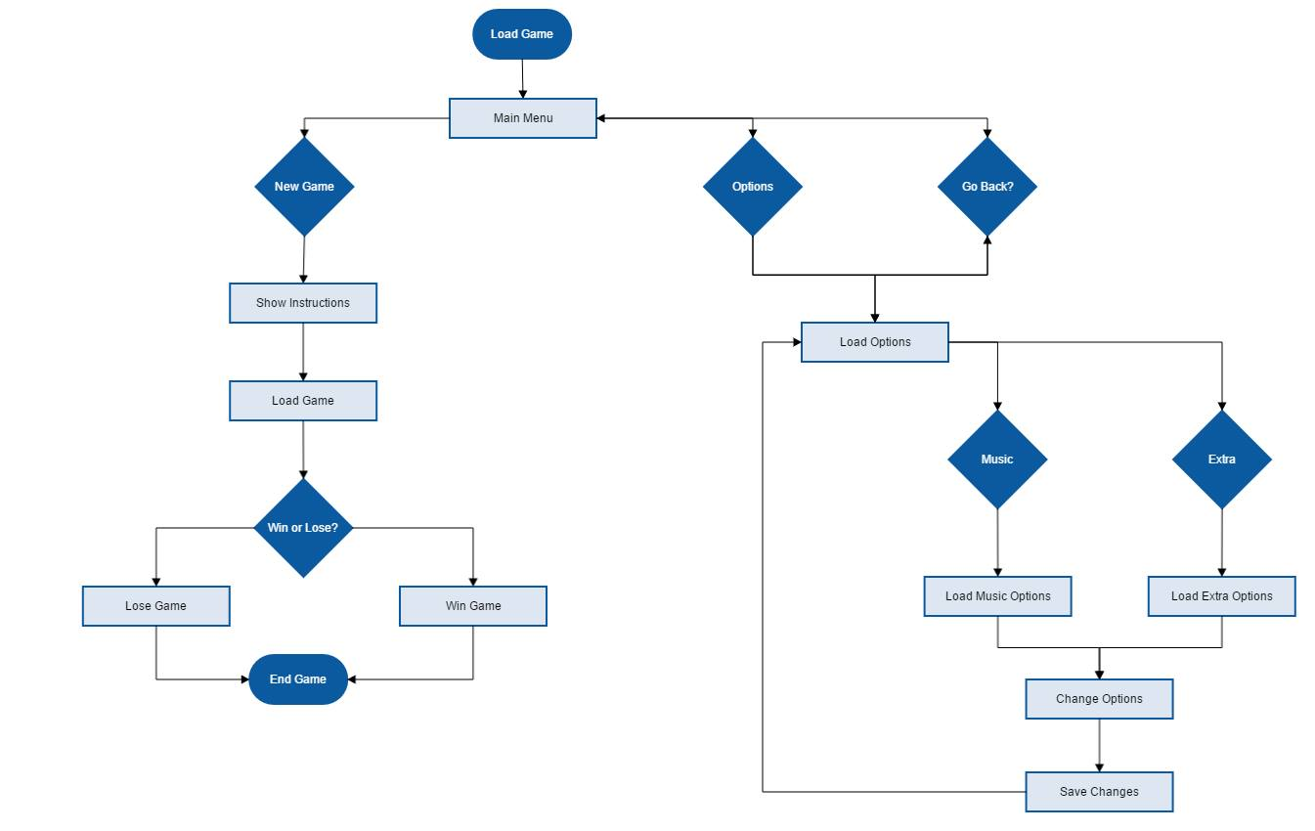

## **Java Code Snippet**

Splash Screen

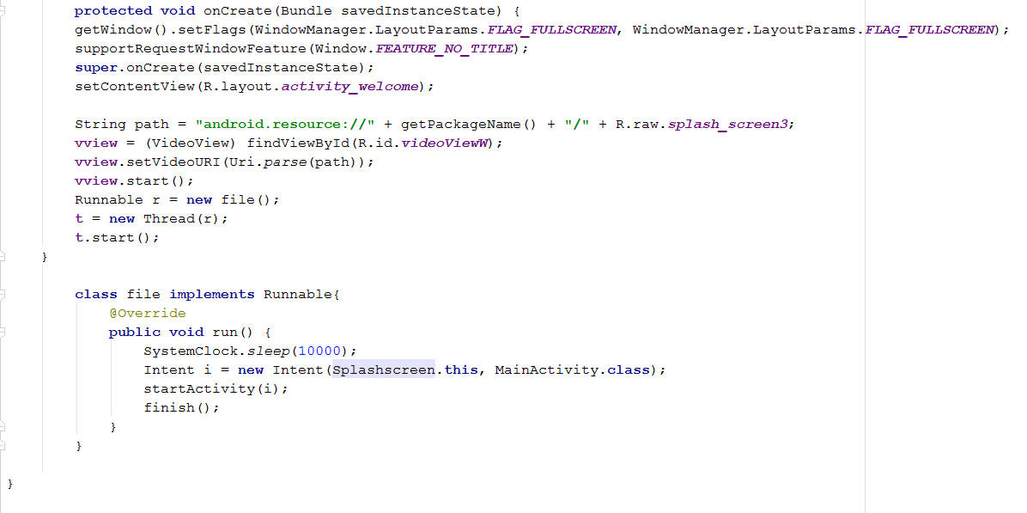

Main Activity

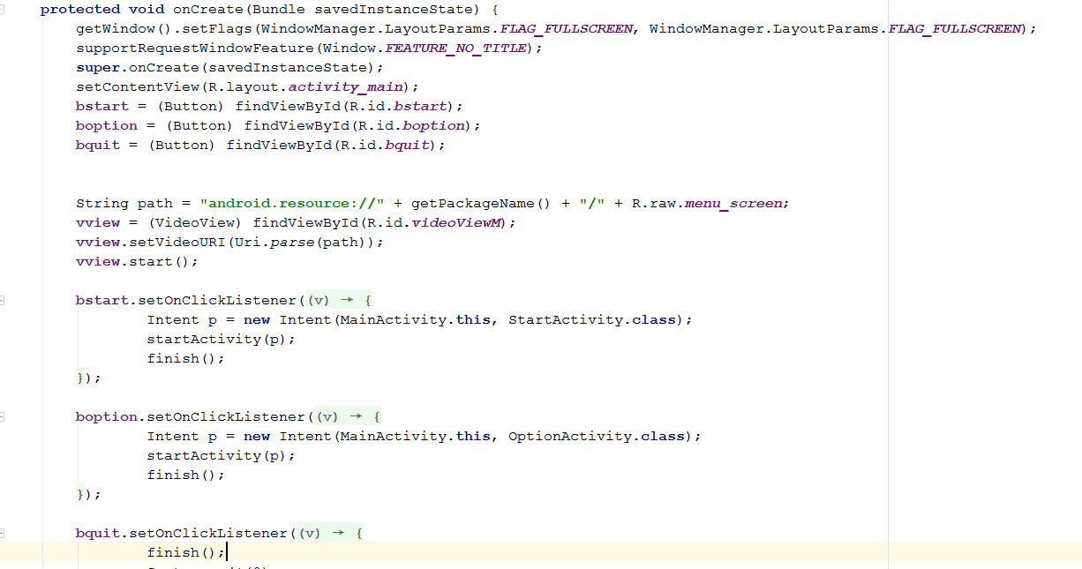

Start Activity

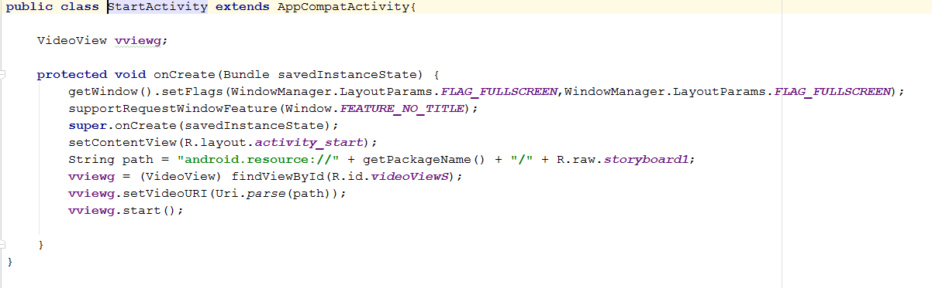

Quit Activity

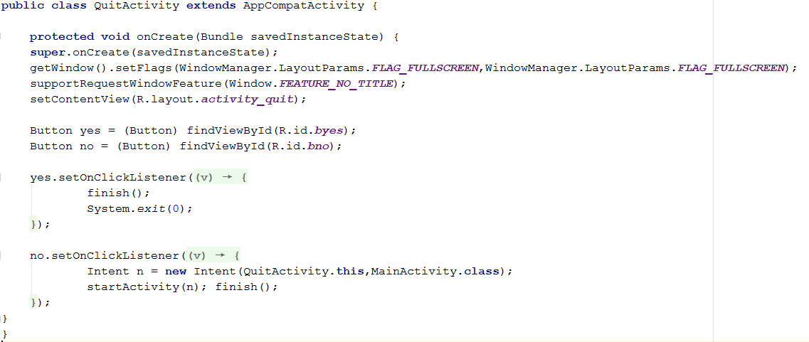

Option Activity

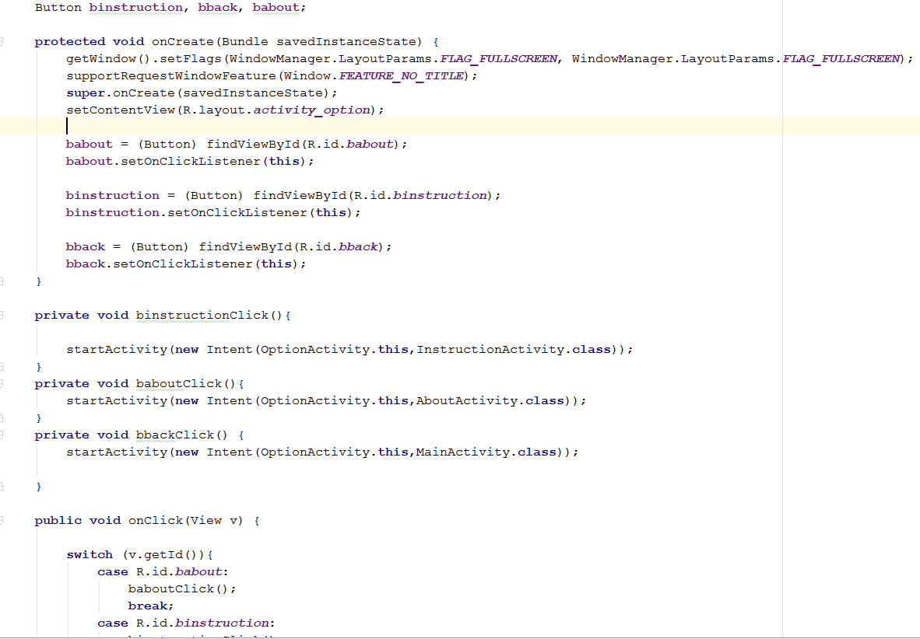

Instruction Activity

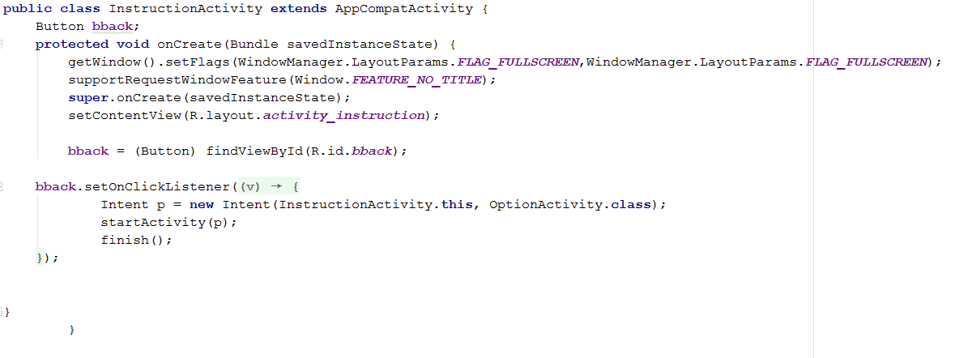

About Activity

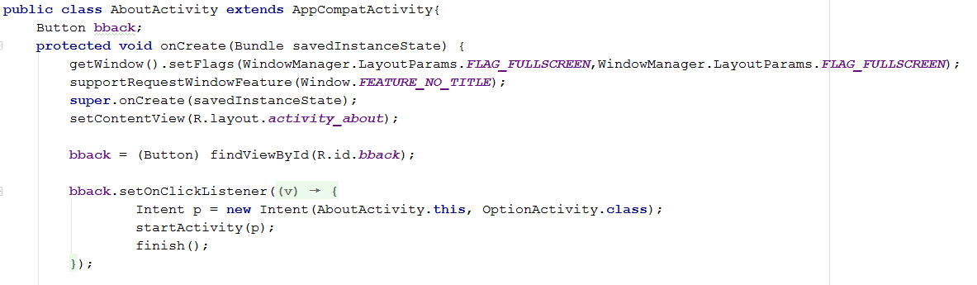

# **Chapter 4**

## **Graphic Assets or Artwork Samples**C:\Users\Jana Marie Gardon\Documents\3rdyr-1stterm\Mobprog\Project\Final\Final\PhHaunted\MyApplication\app\src\main\res\drawable\menuscreen.pngC:\Users\Jana Marie Gardon\Documents\3rdyr-1stterm\Mobprog\Project\Final\Final\PhHaunted\MyApplication\app\src\main\res\drawable\splashscreen.jpg



# **Chapter 5**

## **Resume of each member**

